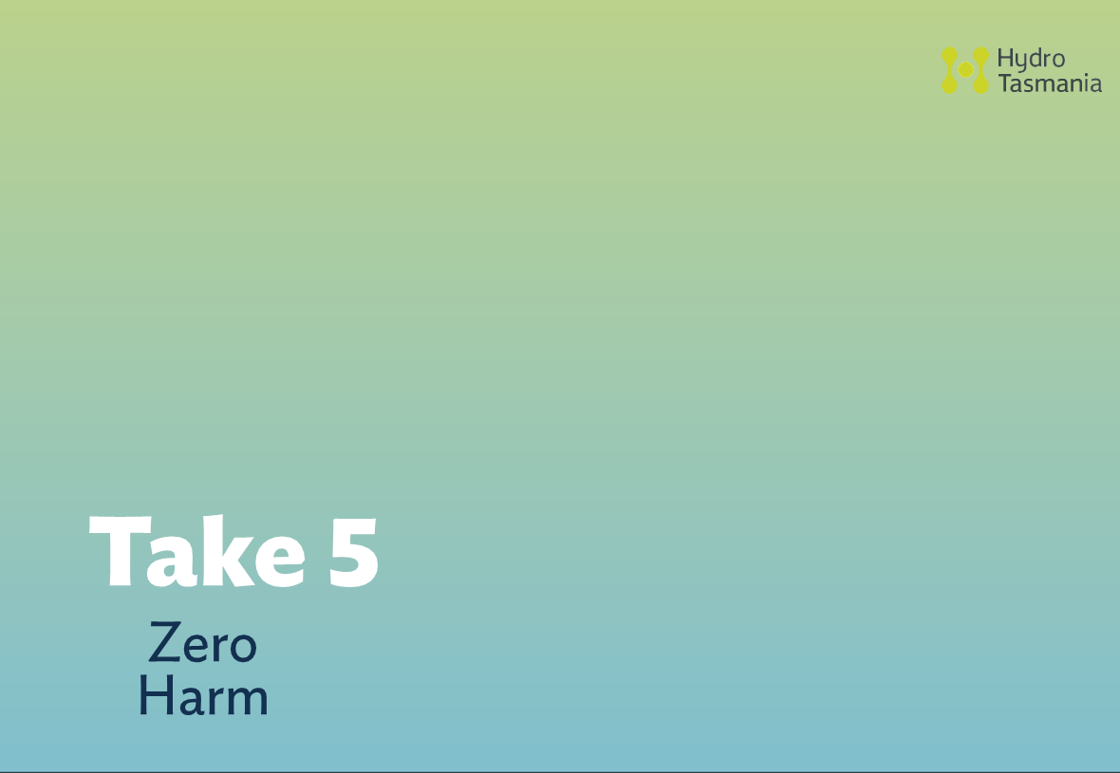
HSEF0301.5 – Take 5. Rev 3.0




CONSEQUENCE
Review SWMS if required for this work
Start Take 5 at job location
Identify hazards,
gs
controls and risk ratin
Complete or amend SWMS for task
Is the Residual Risk Score moderate or above?
NO
YES
Implement controls and perform the task
Have con- ditions changed?
YES
NO
Continue and finish task
HSEF0301.5 – Take 5. Rev 3.0

CONSEQUENCE
Insignificant 1
Minor 2
Moderate 3
Major 4
Extreme 5
Catastrophic 6
LIKELIHOOD
Almost certain 7
7
14
21
28
35
42
Likely 6
6
12
18
24
30
36
Possible 5
5
10
15
20
25
30
Unlikely 4
4
8
12
16
20
24
Rare 3
3
6
9
12
15
18
Extremely Rare
2
2
4
6
8
10
12
Low
Moderate
High
Extreme
Proceed
Complete SWMS
Complete SWMS
Do Not Proceed
LIKELIHOOD
Description
Probability range
Example probability
7. Almost certain
91%-100%
Event is expected
6. Likely
61%-90%
Event is likely to occur
5. Possible
21%-60%
Event may occur, but not likely
4. Unlikely
6%-20%
Event not expected
3. Rare
1%-5%
Event extremely unlikely

2. Extremely Rare

<1%

May occur in extreme and exceptional circumstances

Consequence
1
Insignificant
2
Minor
3
Moderate
4
Major
5
Extreme
6
Catastrophic

Health and Safety

First Aid treatment for minor cuts, bruises etc

Medical treatment injury with no long term impact

Serious injury with anticipated full recovery

Severe injury, temporary disability

Severe injury, permanent disability to one or more persons

One or more fatalities.

Environmental harm

Minimal impact

Localised impact on flora and fauna, oil spill <200L

Ecosystem impact such as fish kill, oil spill <1000L

Significant ecosystem harm with residual effects, oil spill >1000L

Significant ecosystem harm and eventual recovery of ecosystem (i.e. loss of threatened species in region)

Significant ecosystem harm with permanent degradation (i.e. loss of threatened species)

Location: |  |  |  |  | Date:
Task:
Name: |  |  | Initial: | Name: |  | Initial:
SWMS No. |  |  |  |  |  | YES | NO
1 | Do I have safe access / egress?
2 | Can nearby activities injure me?
3 | Can my activities interfere with or injure others?
4 | Can I strain or over exert myself?
5 | Are there enough people to perform this task?
6 | Can I slip or trip on anything?
7 | Can I fall onto, into or from anything?
8 | Can I come into contact with something harmful?
9 | Do I have PPE fit for the task?
10 | Can weather conditions affect my safety?
11 | Do I need a permit for the task?
12 | Can I cause something to fall onto someone?
13 | Are my tools and equipment fit for purpose?
14 | Can I spill or pollute anything?
15 | Is there a safer way to do the task?
16 | Do I need to isolate an energy source?
17 | Are any hazardous substances involved?
18 | Do I have enough time to perform the task?
19 | Am I in a good state of mind for the task?
20 | Are there any other hazards present?
Where a red box is ticked, ensure controls are identified in the table on the rear of this sheet
HSEF0301.5 – Take 5. Rev 3.0

Stop, Look, Assess, Control
Hazard No. | Identify the Hazard, Detail the Control. Rate Original and Residual Risk. | Circle the risk rating
 | Hazard: | L | M | H | E
 | Control: | L | M | H | E
 | Hazard: | L | M | H | E
 | Control: | L | M | H | E
 | Hazard: | L | M | H | E
 | Control: | L | M | H | E
 | Hazard: | L | M | H | E
 | Control: | L | M | H | E
 | Hazard: | L | M | H | E
 | Control: | L | M | H | E
 | Hazard: | L | M | H | E
 | Control: | L | M | H | E
If you circled MODERATE or above for the RESIDUAL risk, a SWMS must be completed.
Check: Have you controlled all possible hazards? Are you Ready To Work Safely?
HSEF0301.5 – Take 5. Rev 3.0

